
DEPARTMENT OF BIOELECTRONICS AND BIOSENSORS
ALAGAPPA UNIVERSITY
(A State University Accredited with ‘A’ Grade by NAAC)
KARAIKUDI – 630 003, TAMILNADU.
-----------------
Dr. C. Sekar 20.12.2012
Professor & Head

ADVERTISEMENT

Applications are invited for the temporary post of one Junior Research Fellow (JRF)/Project Fellow in the IUAC-New Delhi sponsered Research Project entitled “ Effect of Irradiation on the Metal Oxide Semiconducting Nanostructures for Biosensor Applications”.

Funding Agency : Inter-University Accelerator Centre (IUAC), New Delhi

Tenure / Stipend : 2 Years & 8 months / As per UGC Guidelines

Qualification/ : M.Sc. (Bioelectronics & Biosensors/Physics/Chemistry/
Experience Biochemistry/Materials Science or equivalent); M.Sc./M.Tech (NanoScience & Technology); Pass in UGC/NET/CSIR National Tests is preferable.

Date/Time : 09.01.2013/ 10:30 a.m
of Interview

Venue : Dept.Bioelectronics and Biosensors, Science Block
(Vth Floor), Alagappa University, Karaikudi - 630 003.

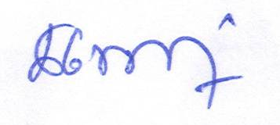
Interested candidates are encouraged to send their resume by email to Sekar2025@gmail.com in advance. No TA/DA will be provided for attending the interview. Selected candidate will be allowed to register for Ph.D. degree.

C. SEKAR

Office: 04565 226385 Mobile: 094425 63637 Email : Sekar2025@gmail.com

